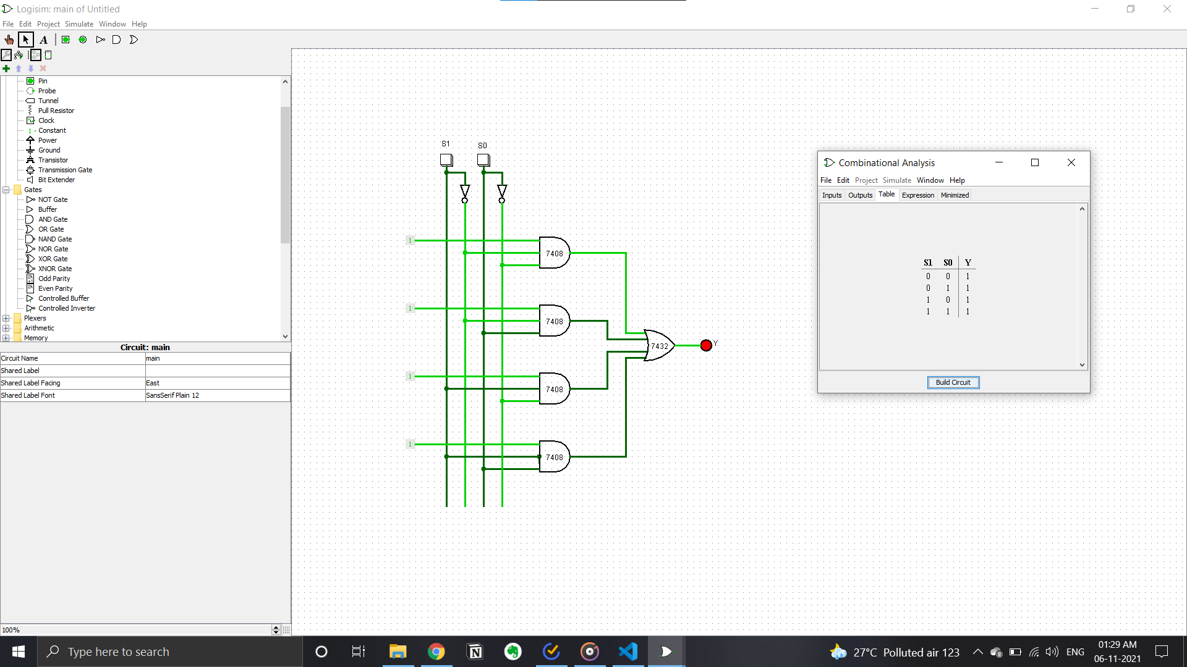**4:1 MUX CIRCUIT**

**1:4 DeMUX CIRCUIT**

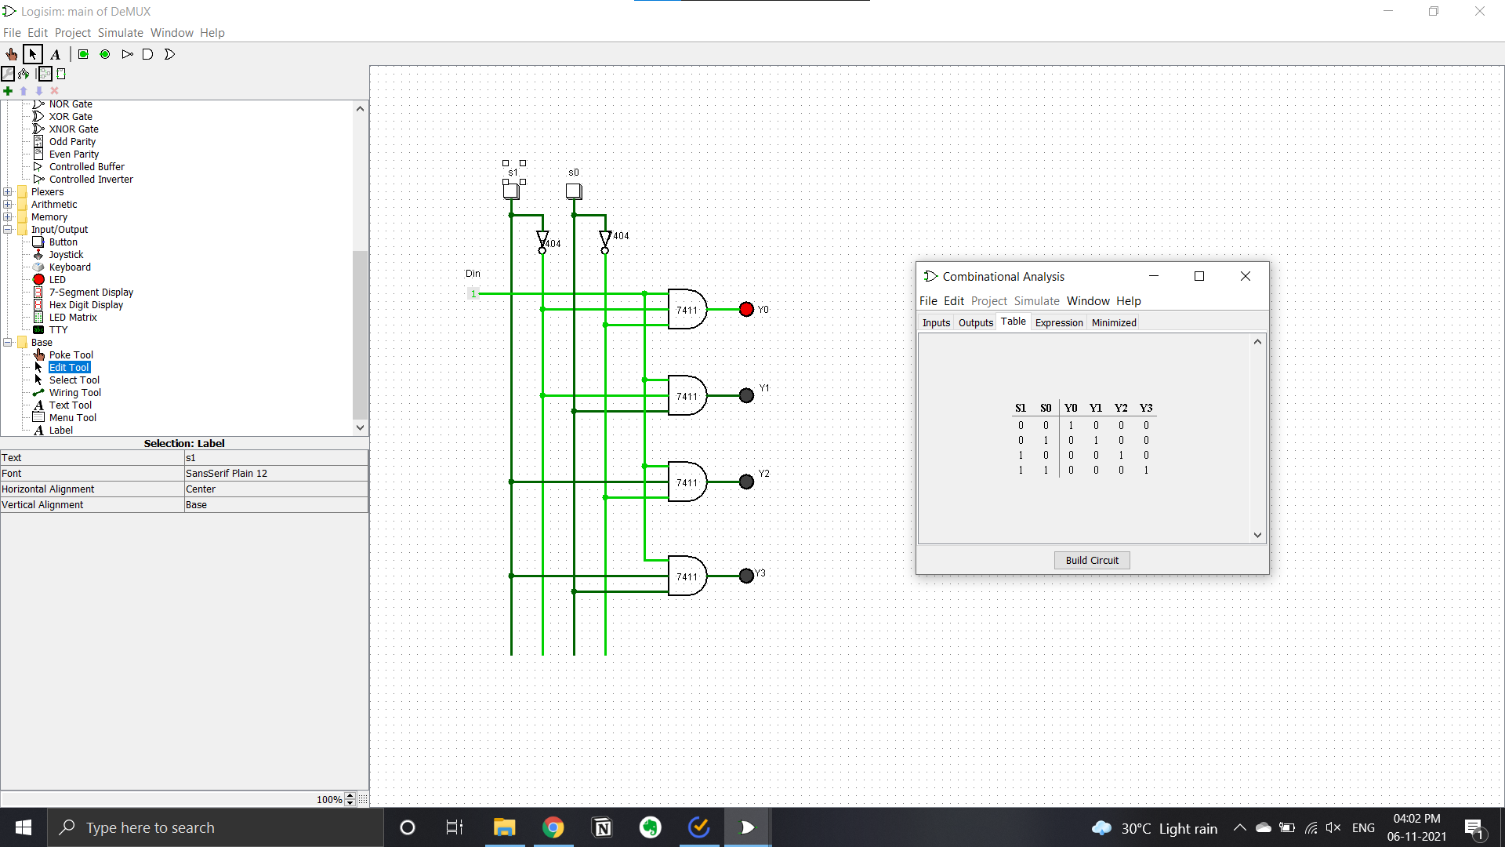

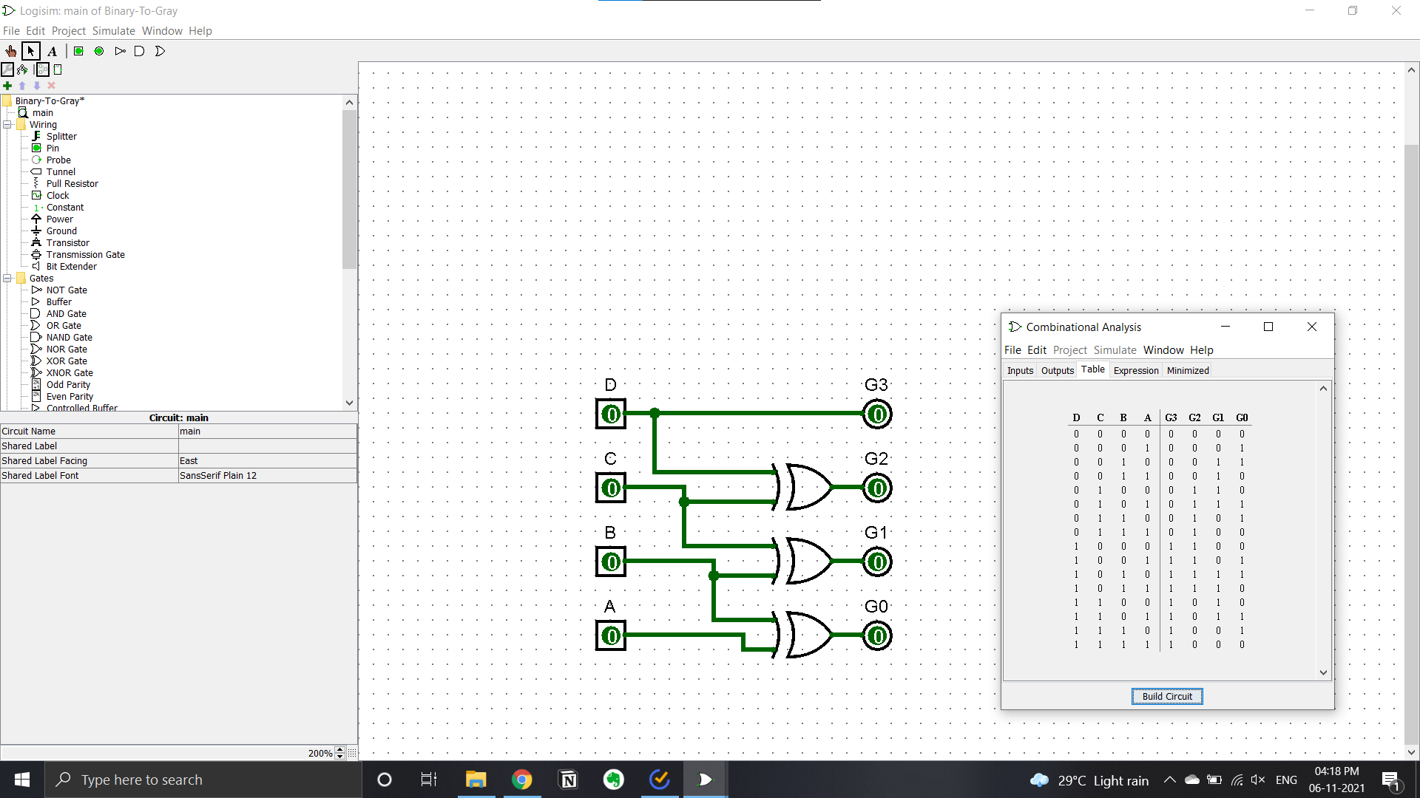**BINARY TO GRAY CONVERTER CIRCUIT**

**GRAY TO BINARY CIRCUIT**

